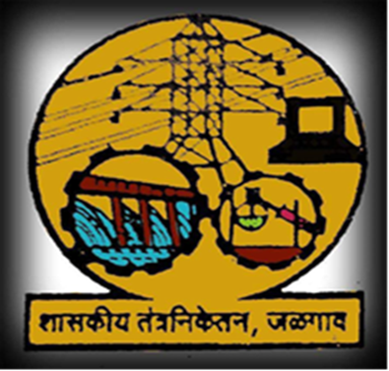

**Government Polytechnic Jalgaon**

Academic Year 2019-20

Course Code

Electrical Circuit And Networks (22330)

EJ 3 I.

**MAHARASHTRA STATE BOARD OF TECHNICAL**

**EDUCATION**

GOVERNMENT POLYTECHNIC, JALGAON

**(0018/1567)**

**Program Name and Code : ELECTRONICS &TELICOMMUNICATION**

**Course Name And Code : Electronic Circuit And Networks (22330)**

**Academic Year : 2019-20**

**Semester : Third.**

**A MICRO PROJECT**

# on

**Thevenins Theorems**

**Submitted on 2019 by the group of 5 students.**

|  |  |  |  |  |
| --- | --- | --- | --- | --- |
| **Sr. No.** | **Roll No.** | **Name of student** | **Enrollment No.** | **Seat No.** |
| **1** | **13** | **Prathamesh saraf** | **1800180265** |  |
| **2** | **29** | **Aakanksha khairnar** | **1800180286** |  |
| **3** | **30** | **Mohit bhangale** | **1800180288** |  |
| **4** | **32** | **Mandar patil** | **1800180290** |  |
| **5** | **33** | **Mohish khadse** | **1800180291** |  |



**MAHARASHTRA STATE BOARD OF TECHNICAL**

**EDUCATION**

**Certificate**

This is to certify that Master Mr/Ms.**Prathamesh,Aakanksha,Mandar,Mohish,Mohit**

Roll No.**13,29,30,32,33** Of **3rd** Semester of Diploma in **E&TC.** of Institute, **Government Polytechnic, Jalgaon** (Code:0018/1567) has completed the **Micro Project** satisfactorily in the Subject  **Electronic Circuit And Networks (22330)** for the Academic Year 2019- 20 as prescribed in the curriculum.

Place**: Jalgaon** Enrollment No:-

**1800180265,1800180286,1800180288,1800180290,1800180291**

Date:-

Exam. Seat No:-

## Subject Teacher Head of the Department Principal

Seal of

Institution

**Thevenins’ Theorem.**

# RATIONAL

In industry, to build and test electronic/electrical circuit in different situation knowledge of electrics circuits and networks is very important. This course is intended to develop the skills to diagnose and rectify the electric network and circuit related problems in industry. The concept and principal of circuits lays the foundation to understand course of higher level.

**AIMS AND BENEFITS OF MICRO PROJECT**

**AIMS:-**

**To understand Thevenin’s theorem** and simplify electrical networks into simple equivalent circuits using the theorem.

**BENEFITS OF MICRO PROJECT:-**

* Thevinians theorem useful to analise the large distributed networks by making it into a voltage source in series with internal impedence.
* It also useful to analyse the performance at any point.this theorem is applicable to both dc and ac networks.after realizing the network as thevenins we easily calculate the maximum power transferred to load.

# COURSE OUTCOMES(COS)

# 

1. Check the functionality using the principle of circuit analysis
2. Use network theorem to determine the various parameter in the circuits

**LITERATURE REVIEW**

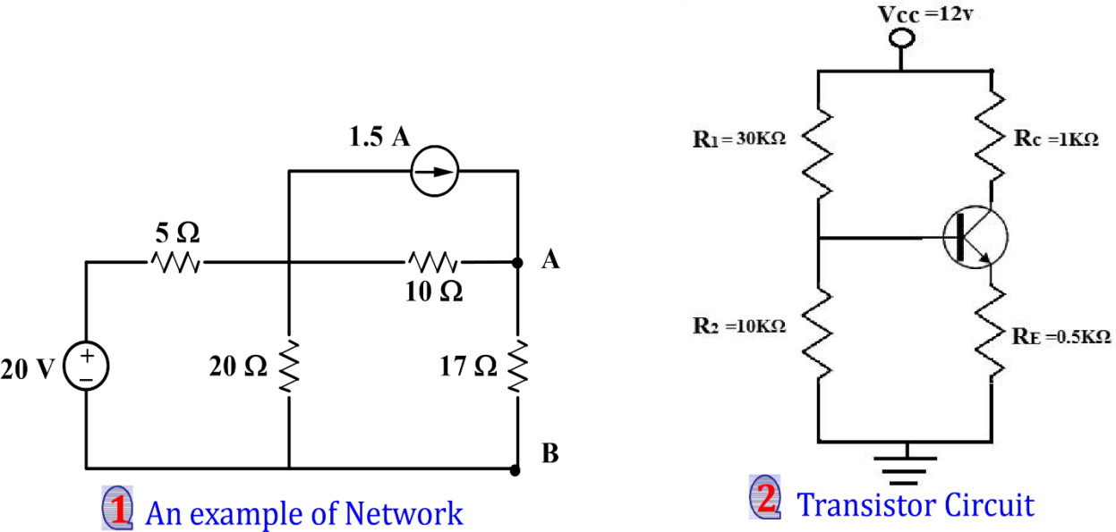

# Thevenin's Theorem

**Thevenin’s theorem** states that a **linear and bilateral network** can be replaced by an equivalent circuit consisting of a voltage source VTh in series with a resistance RTh.

where VTh is the open-circuit voltage across load terminals, and RTh is the input or equivalent resistance at the terminals when all the independent sources are turned off.

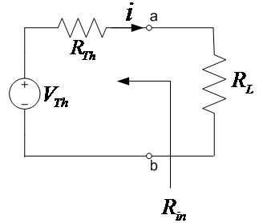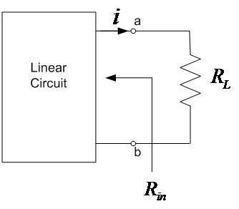

**~~1~~**



**2**

**Determination of RTh (Thevenin’s Resistance):**

The resistance seen by the load, with removed load and all **independent** sources turned off (Voltage sources replaced by short circuits & current sources replaced by open circuits).

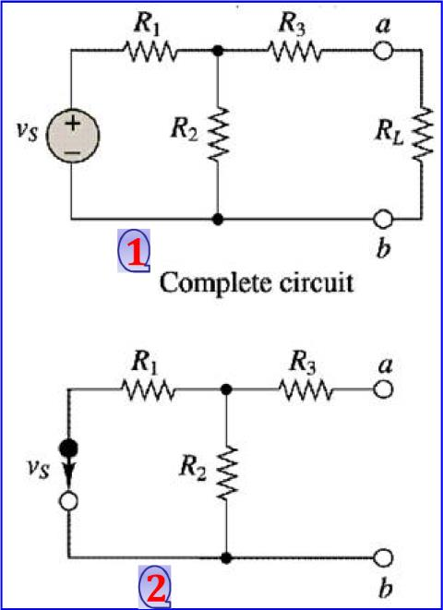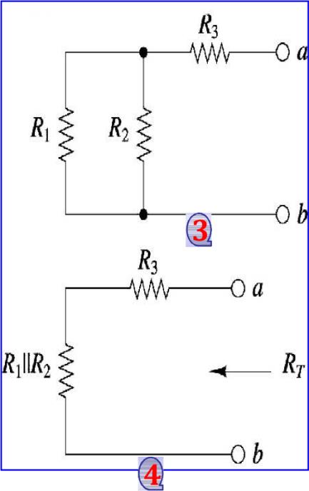

**Determination of VTh (Thevenin’s Voltage):**

The voltage across the load under open circuit condition, also called as open circuit voltage

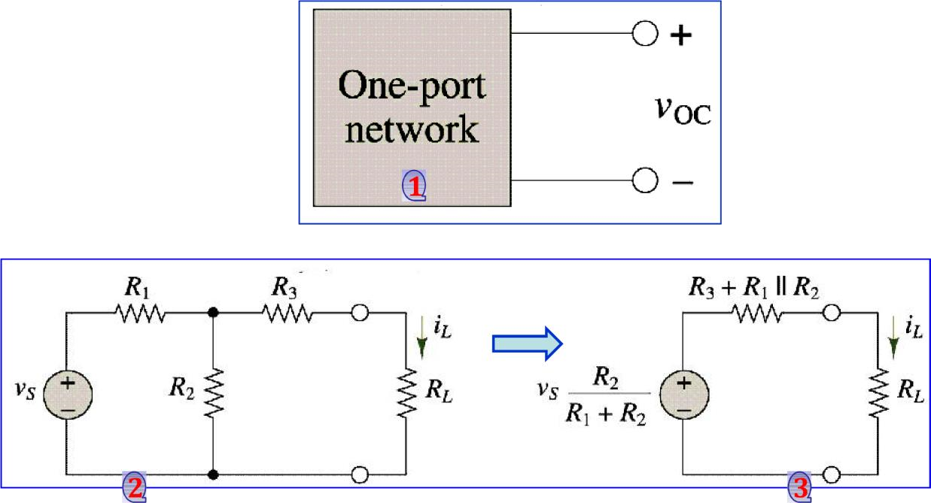

# Example #1

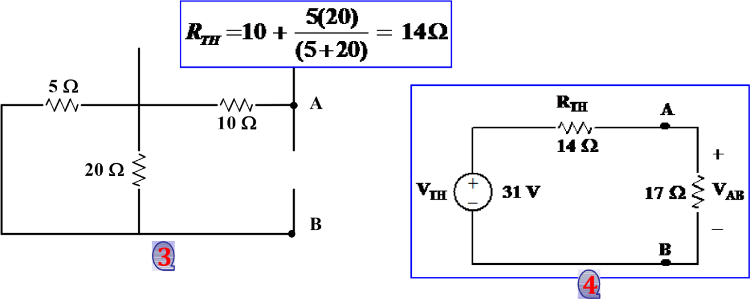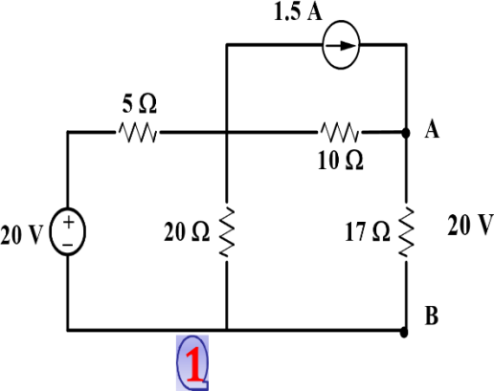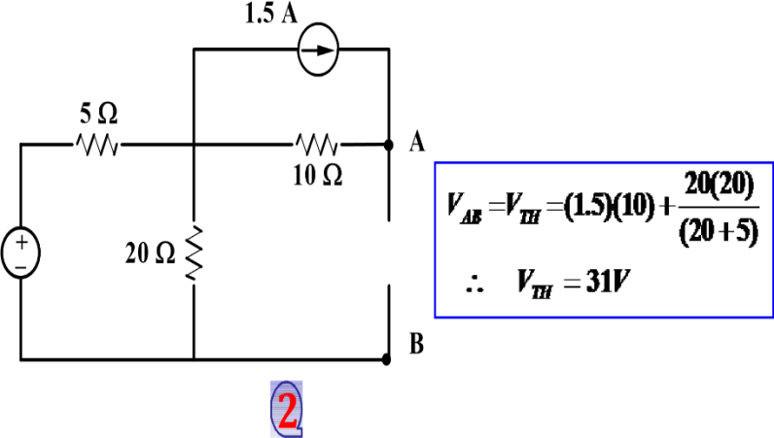

# Example # 2

# 

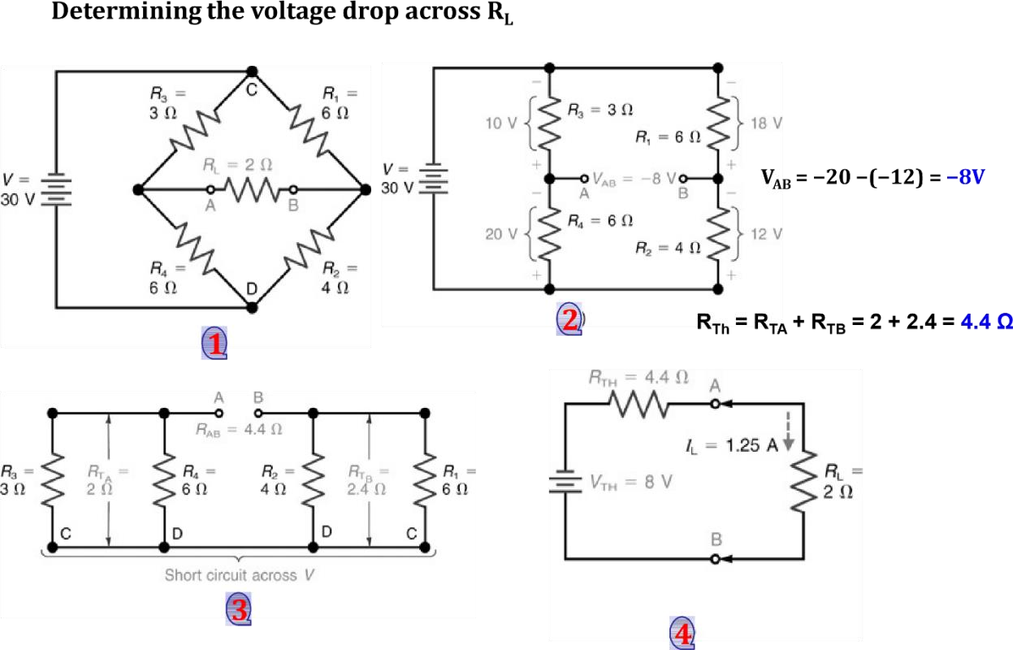

## Actual methodology followed

**Step 1 :** First we discussed the title of micro project.

**Step 2 :** Then we submitted the proposal of micro project.

**Step 3 :** After that we searched the data for our projects.

**Step 4 :** Then we build and tested the circuit in lab.

**Step 5 :** Then we prepared the report.

**Step 6 :** After that we submitted the microproject.

## Actual resources used

## 

|  |  |  |  |
| --- | --- | --- | --- |
| **SR NO** | **Name of materials** | **Specifiacation** | **Quantity** |
| **1** | Resistors | 470ohm and  330ohm,2.2kohm | 3 |
| **2** | Plastic box | DCM power | 1 |
| **3** | Bannana sockets | Female sockets | 2 |
| **4** | Connecting wires | Single stand Teflon | _ |
| **5** | PCB | 0 PCB | 1 |

## LEARNINGS OUTCOMES OF MICRO PEOJECTS

* We learn the application of thevenen’s theorem
* We learn to convert complex circuits into simple circui
* Now we can find the total resistance of complex circuit

**OUTPUTS OF MICRO PROJECTS**

1. **To Find Actual Current Through R :-**

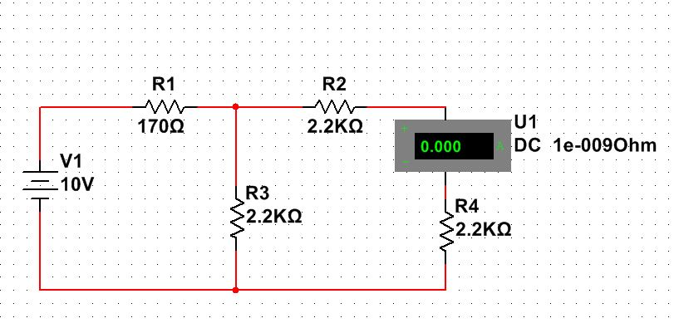

1. **To Measure Thevenins Voltage : -**

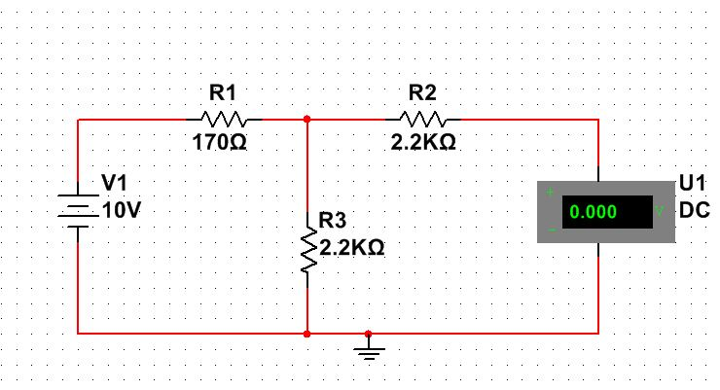

1. **To measure the resistance RN or RTH : -**

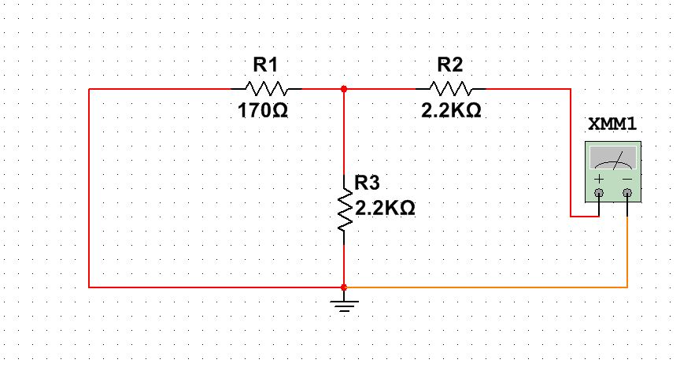

**APPLICATION OF MICRO PROJECTS**

* Itis useful for electrical calculation of the circuits.
* Also used in transmission line drive calculation.
* Also to determine how long it will take a digital signal to go down a bus or a backplane .
* This theorem interesting way to simplify circuit diagram allowing to search partial solution in the selected zone to be analysed.